Final Project Proposal: Park Exploration

Problem statement:

Spring is coming. There are a lot of parks in Philadelphia which are perfect places for people to hang out. This website is aim at helping people navigating accessible parks in the city with showing images and maps, including the history, existing condition, stories of their surrounding neighborhoods and routes to each park.

Data:

Philadelphia parks, points and polygon shapefiles

Philadelphia census tracts shapefile

Philadelphia neighborhood shapefile

Historical stories of each park

Degree of comfort (stored as string, brief intro to the methodology of this estimation)

Technologies used:

Animation of headings when open the website

Story telling layout of website (From intro page, to map page, to story-telling page)

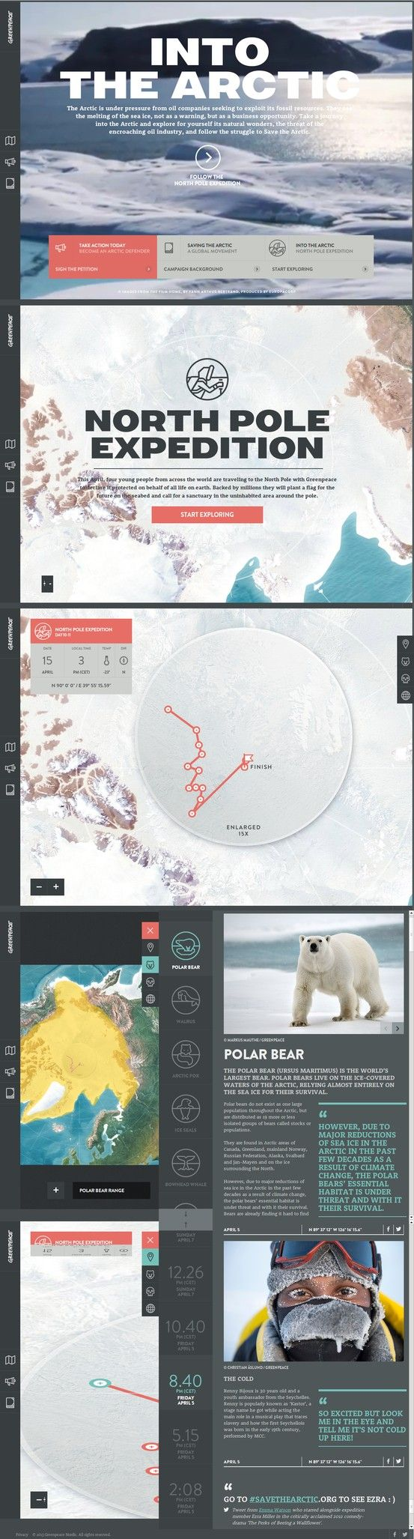User interactive map

Multiple sidebars (menu on the left, clickable icon on the right)

Image collection view

Use external libraries to do the “degree of comfort” analysis

CartoDB analysis tools (If the API is available)

Share via Facebook and Twitter

Design Case Study:

The Park Exploration idea is inspired by the “North Pole Exploration” website.

(<http://www.hellomonday.net/archive/greenpeace/intothearctic/en/)>

Main users are people who want to visit the parks in the city such as tourists and

runners.

They can know the parks better in this website and find out if they are feasible to

Visit and how to visit at that day.

In order to complete similar layout to the case, high-resolution images and customize icons are required in the design process.

Anticipated Difficulties:

Firstly, it may cost a long time to design the layout, images and icons if I want to make it looks professional.

Secondly, I don’t know if it’s possible to get the daily temperature and relative data for each park and then combine them with existing points.

Thirdly, there is going to be a panel showing the degree of comfort and relative data dynamically. It’s difficult to do that since it may require some other APIs from other sources.

Missing Pieces:

Animation of CSS components.

Maybe some other